Nguyễn Trường Hưng – 1150070013 – 11_TMĐT – số máy: 20
BÀI THỰC HÀNH BUỔI 3
Lab 6. Layout and application
Bước 1: Tạo dự án mới
Bước 2: Khai báo các chuỗi trong strings.xml:
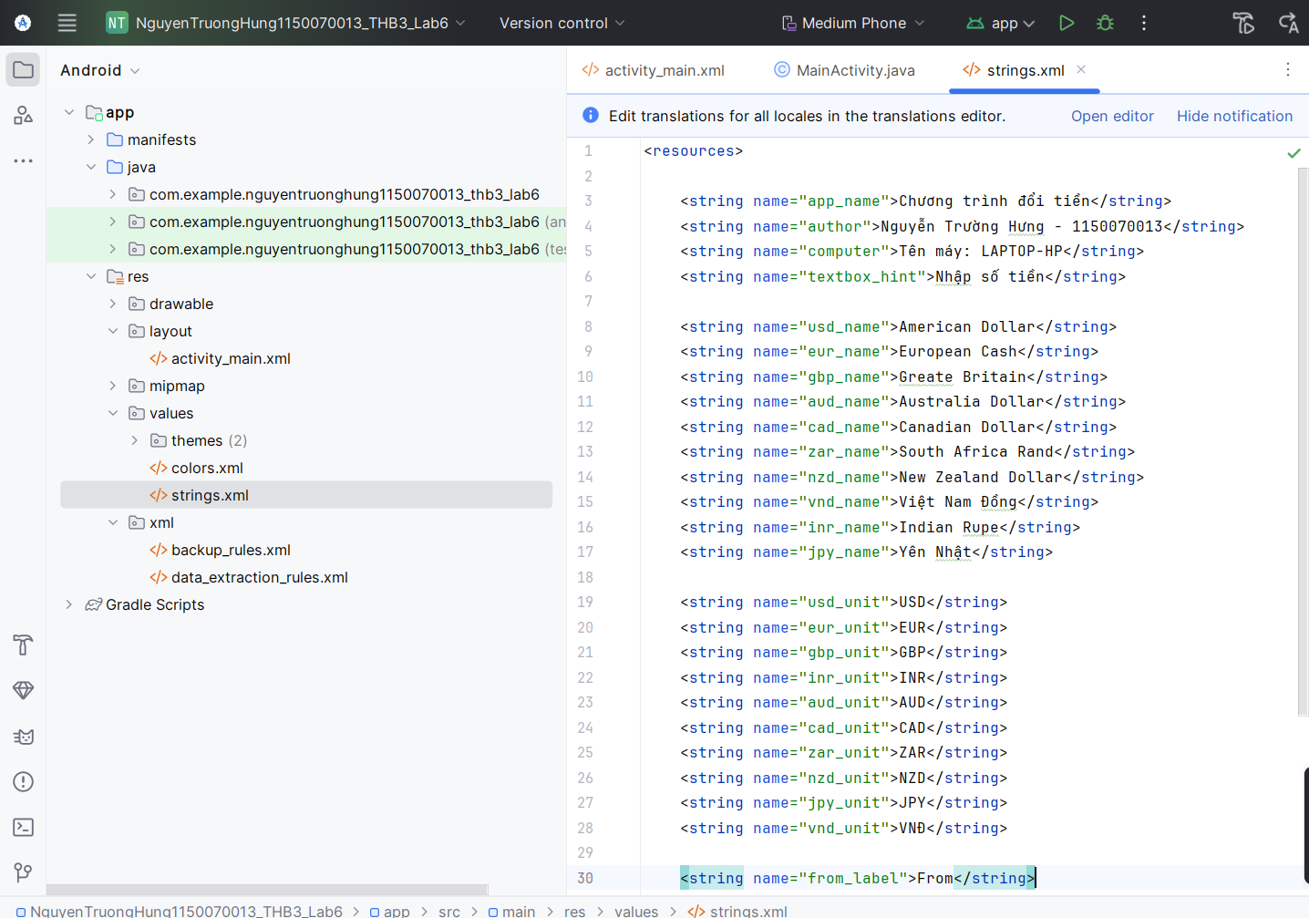

<resources>
<string name="app_name">Chương trình đổi tiền</string>
<string name="author">Nguyễn Trường Hưng - 1150070013</string>
<string name="computer">Tên máy: LAPTOP-HP</string>
<string name="textbox_hint">Nhập số tiền</string>
<string name="usd_name">American Dollar</string>
<string name="eur_name">European Cash</string>
<string name="gbp_name">Greate Britain</string>
<string name="aud_name">Australia Dollar</string>
<string name="cad_name">Canadian Dollar</string>
<string name="zar_name">South Africa Rand</string>
<string name="nzd_name">New Zealand Dollar</string>
<string name="vnd_name">Việt Nam Đồng</string>
<string name="inr_name">Indian Rupe</string>
<string name="jpy_name">Yên Nhật</string>
<string name="usd_unit">USD</string>
<string name="eur_unit">EUR</string>
<string name="gbp_unit">GBP</string>
<string name="inr_unit">INR</string>
<string name="aud_unit">AUD</string>
<string name="cad_unit">CAD</string>
<string name="zar_unit">ZAR</string>
<string name="nzd_unit">NZD</string>
<string name="jpy_unit">JPY</string>
<string name="vnd_unit">VNĐ</string>
<string name="from_label">From</string>
<string name="to_label">To</string>
<string name="btn_convert">Convert</string>
<string name="result_label">Kết quả</string>
</resources>

Bước 3: Chuẩn bị tài nguyên ảnh các quốc gia
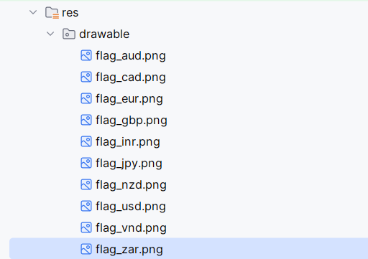

Bước 4: Thiết kế bố cục và giao diện ứng dụng
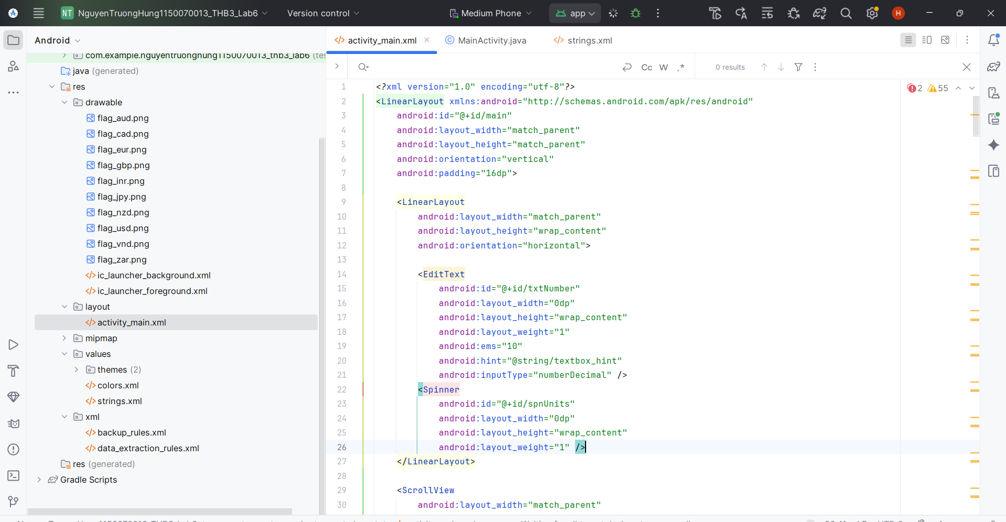
<?xml version="1.0" encoding="utf-8"?>
<LinearLayout xmlns:android="http://schemas.android.com/apk/res/android"
android:id="@+id/main"
android:layout_width="match_parent"
android:layout_height="match_parent"
android:orientation="vertical"
android:padding="16dp">
<LinearLayout
android:layout_width="match_parent"
android:layout_height="wrap_content"
android:orientation="horizontal">
<EditText
android:id="@+id/txtNumber"
android:layout_width="0dp"
android:layout_height="wrap_content"
android:layout_weight="1"
android:ems="10"
android:hint="@string/textbox_hint"
android:inputType="numberDecimal" />
<Spinner
android:id="@+id/spnUnits"
android:layout_width="0dp"
android:layout_height="wrap_content"
android:layout_weight="1" />
</LinearLayout>
<ScrollView
android:layout_width="match_parent"
android:layout_height="0dp"
android:layout_weight="1"
android:fillViewport="true">
<TableLayout
android:layout_width="match_parent"
android:layout_height="wrap_content">
<TableRow
android:layout_width="match_parent"
android:layout_height="wrap_content"
android:padding="3dp"
android:gravity="center_vertical">
<ImageView
android:layout_width="wrap_content"
android:layout_height="wrap_content"
android:src="@drawable/flag_usd"
android:contentDescription="@string/usd_name" />
<TextView
android:layout_width="wrap_content"
android:layout_height="wrap_content"
android:text="@string/usd_name"
android:paddingLeft="10dp" />
<TextView
android:id="@+id/lblUsd"
android:layout_width="wrap_content"
android:layout_height="wrap_content"
android:paddingLeft="10dp"
android:text="0" />
</TableRow>
<TableRow
android:layout_width="match_parent"
android:layout_height="wrap_content"
android:padding="3dp"
android:gravity="center_vertical">
<ImageView
android:layout_width="wrap_content"
android:layout_height="wrap_content"
android:src="@drawable/flag_eur"
android:contentDescription="@string/eur_name" />
<TextView
android:layout_width="wrap_content"
android:layout_height="wrap_content"
android:text="@string/eur_name"
android:paddingLeft="10dp" />
<TextView
android:id="@+id/lblEur"
android:layout_width="wrap_content"
android:layout_height="wrap_content"
android:paddingLeft="10dp"
android:text="0" />
</TableRow>
<TableRow
android:layout_width="match_parent"
android:layout_height="wrap_content"
android:padding="3dp"
android:gravity="center_vertical">
<ImageView
android:layout_width="wrap_content"
android:layout_height="wrap_content"
android:src="@drawable/flag_gbp"
android:contentDescription="@string/gbp_name" />
<TextView
android:layout_width="wrap_content"
android:layout_height="wrap_content"
android:text="@string/gbp_name"
android:paddingLeft="10dp" />
<TextView
android:id="@+id/lblGbp"
android:layout_width="wrap_content"
android:layout_height="wrap_content"
android:paddingLeft="10dp"
android:text="0" />
</TableRow>
<TableRow
android:layout_width="match_parent"
android:layout_height="wrap_content"
android:padding="3dp"
android:gravity="center_vertical">
<ImageView
android:layout_width="wrap_content"
android:layout_height="wrap_content"
android:src="@drawable/flag_inr"
android:contentDescription="@string/inr_name" />
<TextView
android:layout_width="wrap_content"
android:layout_height="wrap_content"
android:text="@string/inr_name"
android:paddingLeft="10dp" />
<TextView
android:id="@+id/lblInr"
android:layout_width="wrap_content"
android:layout_height="wrap_content"
android:paddingLeft="10dp"
android:text="0" />
</TableRow>
<TableRow
android:layout_width="match_parent"
android:layout_height="wrap_content"
android:padding="3dp"
android:gravity="center_vertical">
<ImageView
android:layout_width="wrap_content"
android:layout_height="wrap_content"
android:src="@drawable/flag_aud"
android:contentDescription="@string/aud_name" />
<TextView
android:layout_width="wrap_content"
android:layout_height="wrap_content"
android:text="@string/aud_name"
android:paddingLeft="10dp" />
<TextView
android:id="@+id/lblAud"
android:layout_width="wrap_content"
android:layout_height="wrap_content"
android:paddingLeft="10dp"
android:text="0" />
</TableRow>
<TableRow
android:layout_width="match_parent"
android:layout_height="wrap_content"
android:padding="3dp"
android:gravity="center_vertical">
<ImageView
android:layout_width="wrap_content"
android:layout_height="wrap_content"
android:src="@drawable/flag_cad"
android:contentDescription="@string/cad_name" />
<TextView
android:layout_width="wrap_content"
android:layout_height="wrap_content"
android:text="@string/cad_name"
android:paddingLeft="10dp" />
<TextView
android:id="@+id/lblCad"
android:layout_width="wrap_content"
android:layout_height="wrap_content"
android:paddingLeft="10dp"
android:text="0" />
</TableRow>
<TableRow
android:layout_width="match_parent"
android:layout_height="wrap_content"
android:padding="3dp"
android:gravity="center_vertical">
<ImageView
android:layout_width="wrap_content"
android:layout_height="wrap_content"
android:src="@drawable/flag_zar"
android:contentDescription="@string/zar_name" />
<TextView
android:layout_width="wrap_content"
android:layout_height="wrap_content"
android:text="@string/zar_name"
android:paddingLeft="10dp" />
<TextView
android:id="@+id/lblZar"
android:layout_width="wrap_content"
android:layout_height="wrap_content"
android:paddingLeft="10dp"
android:text="0" />
</TableRow>
<TableRow
android:layout_width="match_parent"
android:layout_height="wrap_content"
android:padding="3dp"
android:gravity="center_vertical">
<ImageView
android:layout_width="wrap_content"
android:layout_height="wrap_content"
android:src="@drawable/flag_nzd"
android:contentDescription="@string/nzd_name" />
<TextView
android:layout_width="wrap_content"
android:layout_height="wrap_content"
android:text="@string/nzd_name"
android:paddingLeft="10dp" />
<TextView
android:id="@+id/lblNzd"
android:layout_width="wrap_content"
android:layout_height="wrap_content"
android:paddingLeft="10dp"
android:text="0" />
</TableRow>
<TableRow
android:layout_width="match_parent"
android:layout_height="wrap_content"
android:padding="3dp"
android:gravity="center_vertical">
<ImageView
android:layout_width="wrap_content"
android:layout_height="wrap_content"
android:src="@drawable/flag_jpy"
android:contentDescription="@string/jpy_name" />
<TextView
android:layout_width="wrap_content"
android:layout_height="wrap_content"
android:text="@string/jpy_name"
android:paddingLeft="10dp" />
<TextView
android:id="@+id/lblJpy"
android:layout_width="wrap_content"
android:layout_height="wrap_content"
android:paddingLeft="10dp"
android:text="0" />
</TableRow>
<TableRow
android:layout_width="match_parent"
android:layout_height="wrap_content"
android:padding="3dp"
android:gravity="center_vertical">
<ImageView
android:layout_width="wrap_content"
android:layout_height="wrap_content"
android:src="@drawable/flag_vnd"
android:contentDescription="@string/vnd_name" />
<TextView
android:layout_width="wrap_content"
android:layout_height="wrap_content"
android:text="@string/vnd_name"
android:paddingLeft="10dp" />
<TextView
android:id="@+id/lblVnd"
android:layout_width="wrap_content"
android:layout_height="wrap_content"
android:paddingLeft="10dp"
android:text="0" />
</TableRow>
</TableLayout>
</ScrollView>
</LinearLayout>

Bước 5: Thiết lập dữ liệu và xử lý sự kiện cho ứng dụng
package com.example.nguyentruonghung1150070013_thb3_lab6;
import android.os.Bundle;
import android.text.Editable;
import android.text.TextWatcher;
import android.widget.ArrayAdapter;
import android.widget.EditText;
import android.widget.Spinner;
import android.widget.TextView;
import android.widget.AdapterView;
import android.view.View;
import androidx.activity.EdgeToEdge;
import androidx.appcompat.app.AppCompatActivity;
import androidx.core.graphics.Insets;
import androidx.core.view.ViewCompat;
import androidx.core.view.WindowInsetsCompat;
public class MainActivity extends AppCompatActivity {
private String[] units = {
"USD", "EUR", "GBP", "INR", "AUD",
"CAD", "ZAR", "NZD", "JPY", "VND"
};
private double[][] ratio = {
/*USD*/ { 1.00000, 0.80518, 0.64070, 63.3318, 1.21828, 1.16236, 11.7129, 1.29310, 118.337, 21385.7 },
/*EUR*/ { 1.24172, 1.00000, 0.79575, 78.6084, 1.51266, 1.44314, 14.5371, 1.60576, 146.927, 26561.8 },
/*GBP*/ { 1.56044, 1.25667, 1.00000, 98.7848, 1.90091, 1.81355, 18.2683, 2.01791, 184.638, 33374.9 },
/*INR*/ { 0.01580, 0.01272, 0.01012, 1.00000, 0.01924, 0.01836, 0.18493, 0.02043, 1.86910, 337.811 },
/*AUD*/ { 0.82114, 0.66119, 0.52620, 52.0860, 1.00000, 0.95416, 9.61148, 1.06158, 97.1120, 17567.9 },
/*CAD*/ { 0.86059, 0.69296, 0.55148, 54.5885, 1.04804, 1.00000, 10.0732, 1.11258, 101.777, 18401.7 },
/*ZAR*/ { 0.08541, 0.06877, 0.05473, 5.40852, 0.10398, 0.09924, 1.00000, 0.11037, 10.0996, 1825.87 },
/*NZD*/ { 0.77402, 0.62319, 0.49597, 49.0031, 0.94215, 0.89951, 9.06754, 1.00000, 91.5139, 16552.1 },
/*JPY*/ { 0.00846, 0.00681, 0.00542, 0.53547, 0.01030, 0.00983, 0.09908, 0.01093, 1.00000, 180.837 },
/*VND*/ { 0.00005, 0.00004, 0.00003, 0.00296, 0.00006, 0.00005, 0.00055, 0.00006, 0.00553, 1.00000 }
};
private EditText txtNumber;
private Spinner spnUnits;
private TextView[] lblResults;
@Override
protected void onCreate(Bundle savedInstanceState) {
super.onCreate(savedInstanceState);
EdgeToEdge.enable(this);
setContentView(R.layout.activity_main);
ViewCompat.setOnApplyWindowInsetsListener(findViewById(R.id.main), (v, insets) -> {
Insets systemBars = insets.getInsets(WindowInsetsCompat.Type.systemBars());
v.setPadding(systemBars.left, systemBars.top, systemBars.right, systemBars.bottom);
return insets;
});
txtNumber = findViewById(R.id.txtNumber);
spnUnits = findViewById(R.id.spnUnits);
lblResults = new TextView[] {
(TextView) findViewById(R.id.lblUsd),
(TextView) findViewById(R.id.lblEur),
(TextView) findViewById(R.id.lblGbp),
(TextView) findViewById(R.id.lblInr),
(TextView) findViewById(R.id.lblAud),
(TextView) findViewById(R.id.lblCad),
(TextView) findViewById(R.id.lblZar),
(TextView) findViewById(R.id.lblNzd),
(TextView) findViewById(R.id.lblJpy),
(TextView) findViewById(R.id.lblVnd)
};
ArrayAdapter<String> adapter = new ArrayAdapter<>(
MainActivity.this,
android.R.layout.simple_spinner_item,
units
);
adapter.setDropDownViewResource(android.R.layout.simple_list_item_1);
spnUnits.setAdapter(adapter);
spnUnits.setOnItemSelectedListener(new AdapterView.OnItemSelectedListener() {
@Override
public void onItemSelected(AdapterView<?> parent, View view, int position, long id) {
changeMoneyUnit();
}
@Override
public void onNothingSelected(AdapterView<?> parent) { }
});
txtNumber.addTextChangedListener(new TextWatcher() {
@Override
public void beforeTextChanged(CharSequence s, int start, int count, int after) { }
@Override
public void onTextChanged(CharSequence s, int start, int before, int count) {
changeMoneyUnit();
}
@Override
public void afterTextChanged(Editable s) { }
});
changeMoneyUnit();
}
private void changeMoneyUnit() {
int rowIdx = spnUnits.getSelectedItemPosition();
if (rowIdx < 0) rowIdx = 0;
String input = txtNumber.getText().toString();
if (input.isEmpty()) {
input = "0";
}
double number;
try {
number = Double.valueOf(input);
} catch (NumberFormatException e) {
number = 0;
}
for (int i = 0; i < lblResults.length; i++) {
double temp = number * ratio[rowIdx][i];
lblResults[i].setText(String.valueOf(temp));
}
}
}

kết quả ứng dụng:
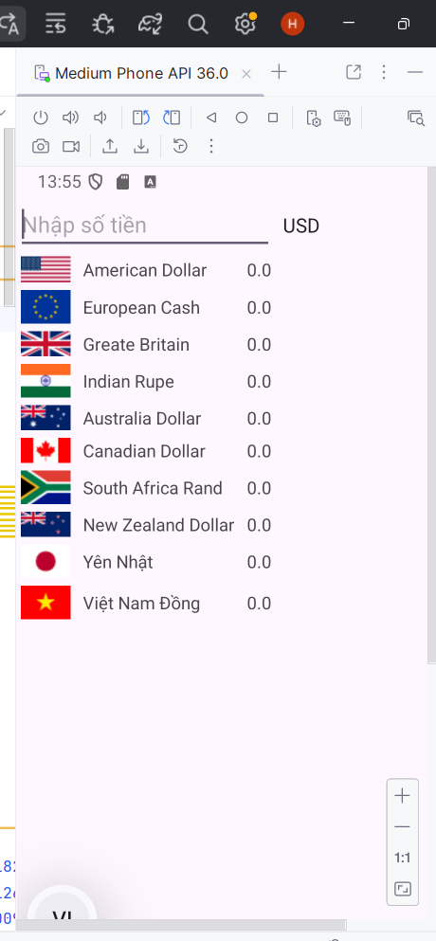
Nhập thử số tiền:
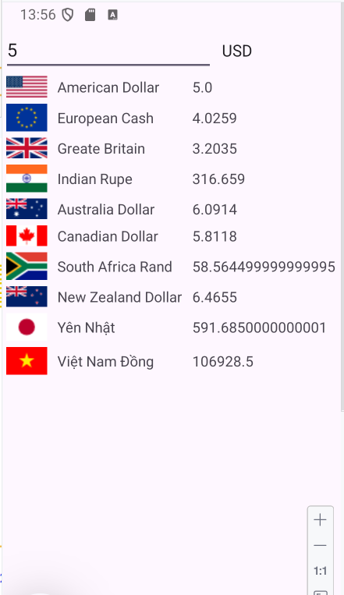

Bài tập: Xây dựng chương trình đổi độ dài
Tương tự như bài luyện tập trên, ta xây dựng chương trình đổi độ dài
Bước 1: Thiết kế giao diện
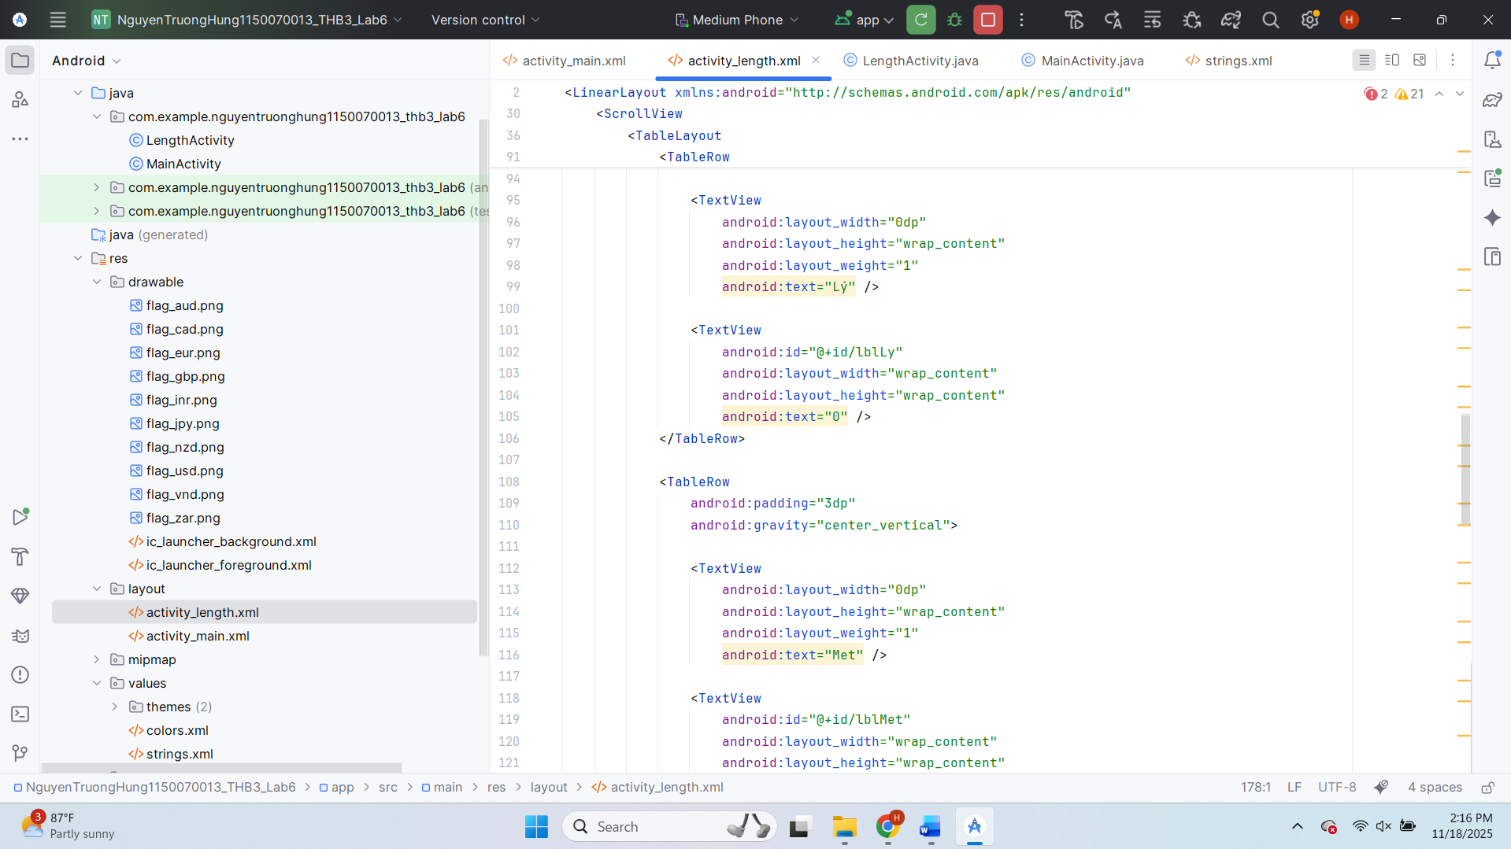
Bước 2: Thiết lập dữ liệu và xử lý sự kiện cho ứng dụng
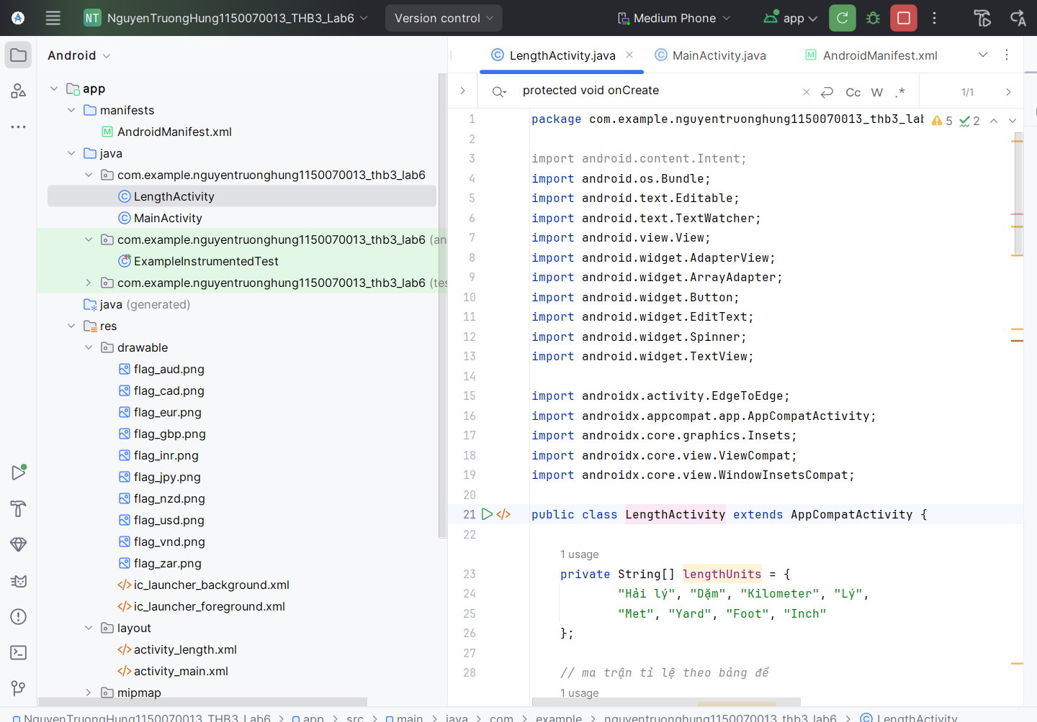

Màn hình kết quả:
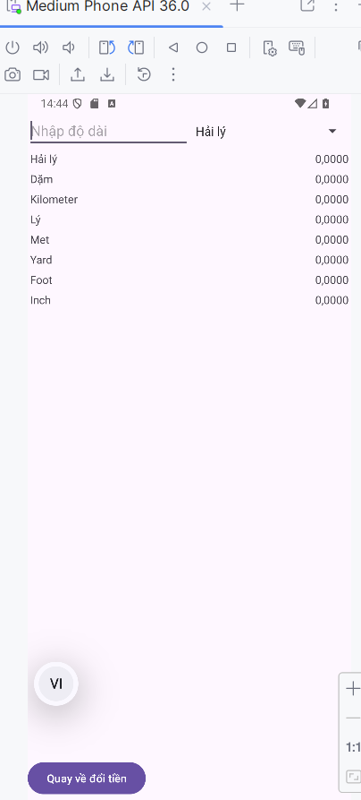
Chuyển đổi đơn vị:
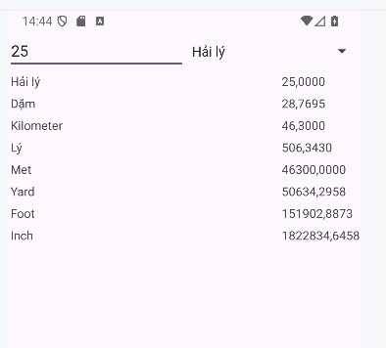

Lab 7. Custom controls
Bước 1: Tạo Activity mới
Bước 2 – Thêm layout cho CustomButtonActivity
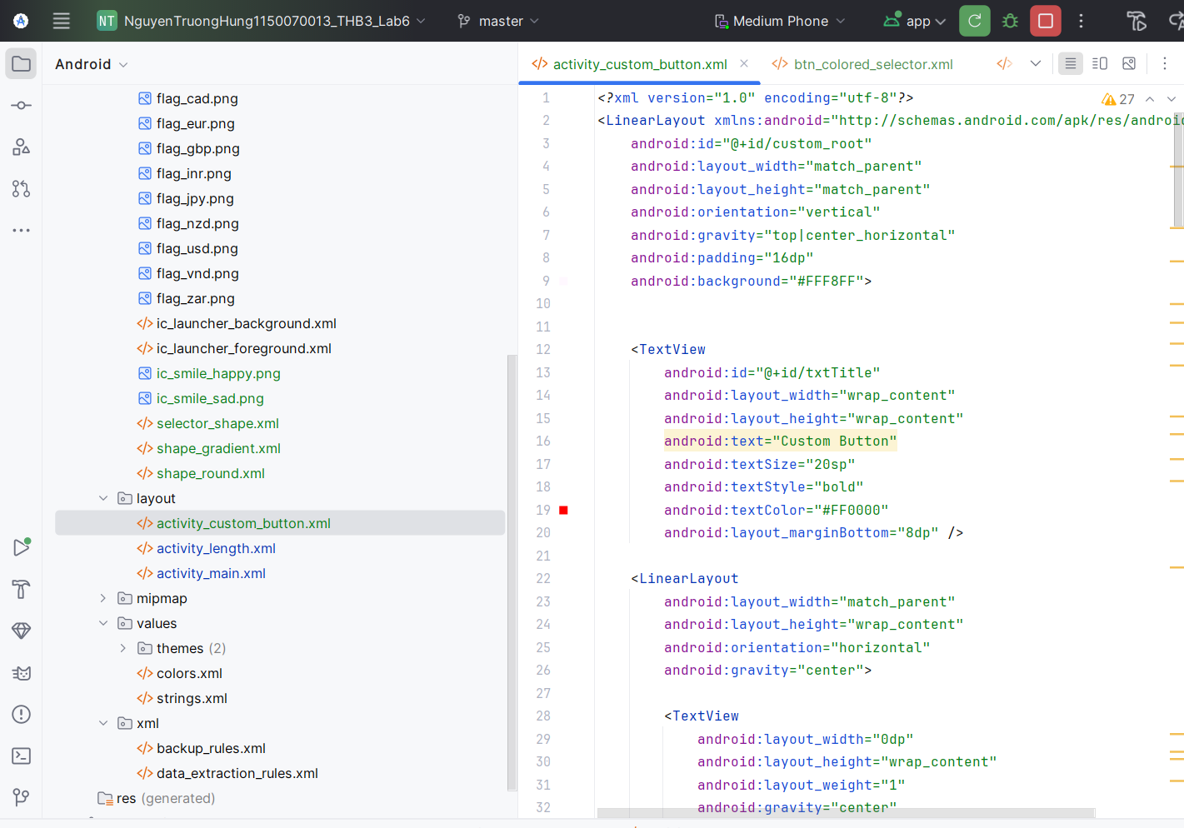
<?xml version="1.0" encoding="utf-8"?>
<LinearLayout xmlns:android="http://schemas.android.com/apk/res/android"
android:id="@+id/custom_root"
android:layout_width="match_parent"
android:layout_height="match_parent"
android:orientation="vertical"
android:gravity="top|center_horizontal"
android:padding="16dp"
android:background="#FFF8FF">
<TextView
android:id="@+id/txtTitle"
android:layout_width="wrap_content"
android:layout_height="wrap_content"
android:text="Custom Button"
android:textSize="20sp"
android:textStyle="bold"
android:textColor="#FF0000"
android:layout_marginBottom="8dp" />
<LinearLayout
android:layout_width="match_parent"
android:layout_height="wrap_content"
android:orientation="horizontal"
android:gravity="center">
<TextView
android:layout_width="0dp"
android:layout_height="wrap_content"
android:layout_weight="1"
android:gravity="center"
android:text="Selectors"
android:textSize="12sp"
android:textStyle="italic" />
<TextView
android:layout_width="0dp"
android:layout_height="wrap_content"
android:layout_weight="1"
android:gravity="center"
android:text="Shapes+Selectors"
android:textSize="12sp"
android:textStyle="italic" />
</LinearLayout>
<LinearLayout
android:layout_width="match_parent"
android:layout_height="wrap_content"
android:orientation="horizontal"
android:gravity="center"
android:layout_marginTop="8dp">
<Button
android:id="@+id/btnColoredSelector"
android:layout_width="0dp"
android:layout_height="wrap_content"
android:layout_weight="1"
android:text="COLORED SELECTOR"
android:textAllCaps="true"
android:textSize="12sp"
android:textColor="#000000"
android:background="@drawable/btn_colored_selector" />
<Button
android:id="@+id/btnRoundShape"
android:layout_width="0dp"
android:layout_height="wrap_content"
android:layout_weight="1"
android:layout_marginStart="8dp"
android:text="ROUND SHAPE"
android:textAllCaps="true"
android:textSize="12sp"
android:textColor="#000000"
android:background="@drawable/shape_round" />
</LinearLayout>
<LinearLayout
android:layout_width="match_parent"
android:layout_height="wrap_content"
android:orientation="horizontal"
android:gravity="center"
android:layout_marginTop="8dp">
<Button
android:id="@+id/btnColoredSelectorDisabled"
android:layout_width="0dp"
android:layout_height="wrap_content"
android:layout_weight="1"
android:text="COLOR SELECTOR\nDISABLED"
android:textAllCaps="true"
android:textSize="11sp"
android:textColor="#000000"
android:enabled="false"
android:background="@drawable/btn_colored_selector_disabled" />
<Button
android:id="@+id/btnShapeGradient"
android:layout_width="0dp"
android:layout_height="wrap_content"
android:layout_weight="1"
android:layout_marginStart="8dp"
android:text="SHAPE WITH GRADIENT"
android:textAllCaps="true"
android:textSize="11sp"
android:textColor="#000000"
android:background="@drawable/shape_gradient" />
</LinearLayout>
<LinearLayout
android:layout_width="match_parent"
android:layout_height="wrap_content"
android:orientation="horizontal"
android:gravity="center"
android:layout_marginTop="8dp">
<View
android:layout_width="0dp"
android:layout_height="0dp"
android:layout_weight="1" />
<Button
android:id="@+id/btnSelectorShape"
android:layout_width="0dp"
android:layout_height="wrap_content"
android:layout_weight="1"
android:text="SELECTOR SHAPE"
android:textAllCaps="true"
android:textSize="11sp"
android:textColor="#FFFFFF"
android:background="@drawable/selector_shape" />
<View
android:layout_width="0dp"
android:layout_height="0dp"
android:layout_weight="1" />
</LinearLayout>
<LinearLayout
android:layout_width="match_parent"
android:layout_height="wrap_content"
android:orientation="vertical"
android:gravity="center"
android:layout_marginTop="16dp">
<ImageButton
android:id="@+id/imgHappy"
android:layout_width="72dp"
android:layout_height="72dp"
android:background="@drawable/emoji_bg"
android:src="@drawable/ic_smile_happy"
android:scaleType="centerInside"
android:contentDescription="@string/app_name" />
<ImageButton
android:id="@+id/imgSad"
android:layout_width="72dp"
android:layout_height="72dp"
android:layout_marginTop="8dp"
android:background="@drawable/emoji_bg"
android:src="@drawable/ic_smile_sad"
android:scaleType="centerInside"
android:contentDescription="@string/app_name" />
</LinearLayout>
<LinearLayout
android:layout_width="match_parent"
android:layout_height="wrap_content"
android:orientation="horizontal"
android:gravity="center"
android:layout_marginTop="24dp">
<Button
android:id="@+id/btnBackMoney"
android:layout_width="0dp"
android:layout_height="wrap_content"
android:layout_weight="1"
android:text="Quay về đổi tiền" />
<Button
android:id="@+id/btnGoLength"
android:layout_width="0dp"
android:layout_height="wrap_content"
android:layout_weight="1"
android:layout_marginStart="8dp"
android:text="Sang đổi độ dài" />
</LinearLayout>
</LinearLayout>

Bước 3 – Tạo các file shape / selector

btn_colored_selector.xml – nút xanh nhấn đổi màu:
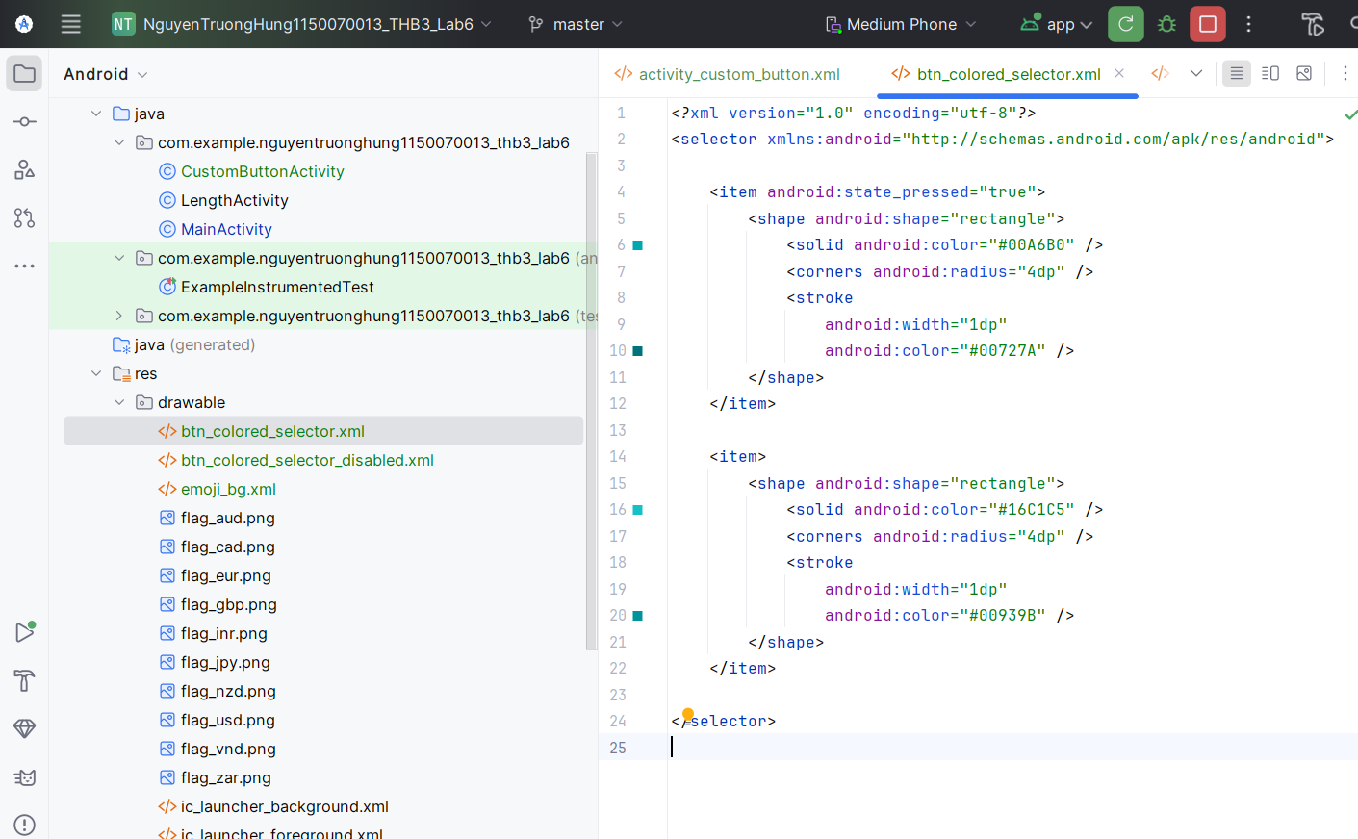

btn_colored_selector_disabled.xml – nút vàng bị disable:
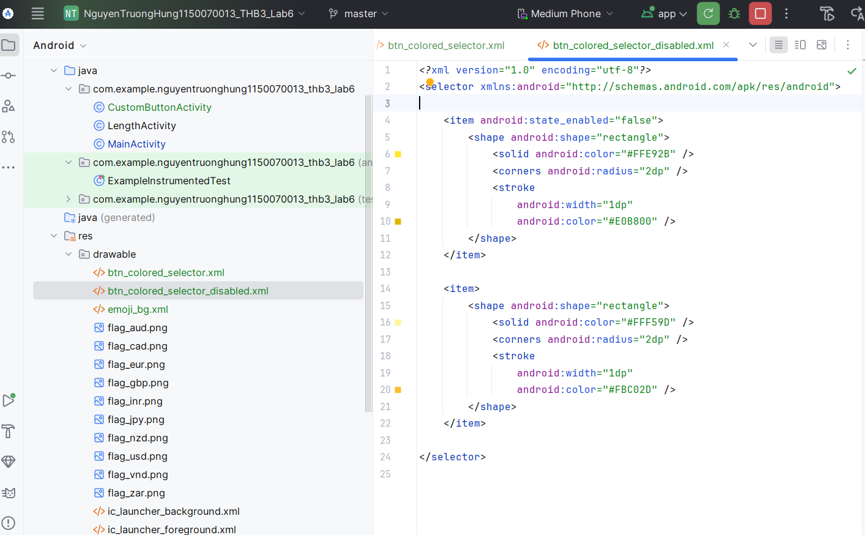

shape_round.xml – nút bo tròn trắng viền xám:
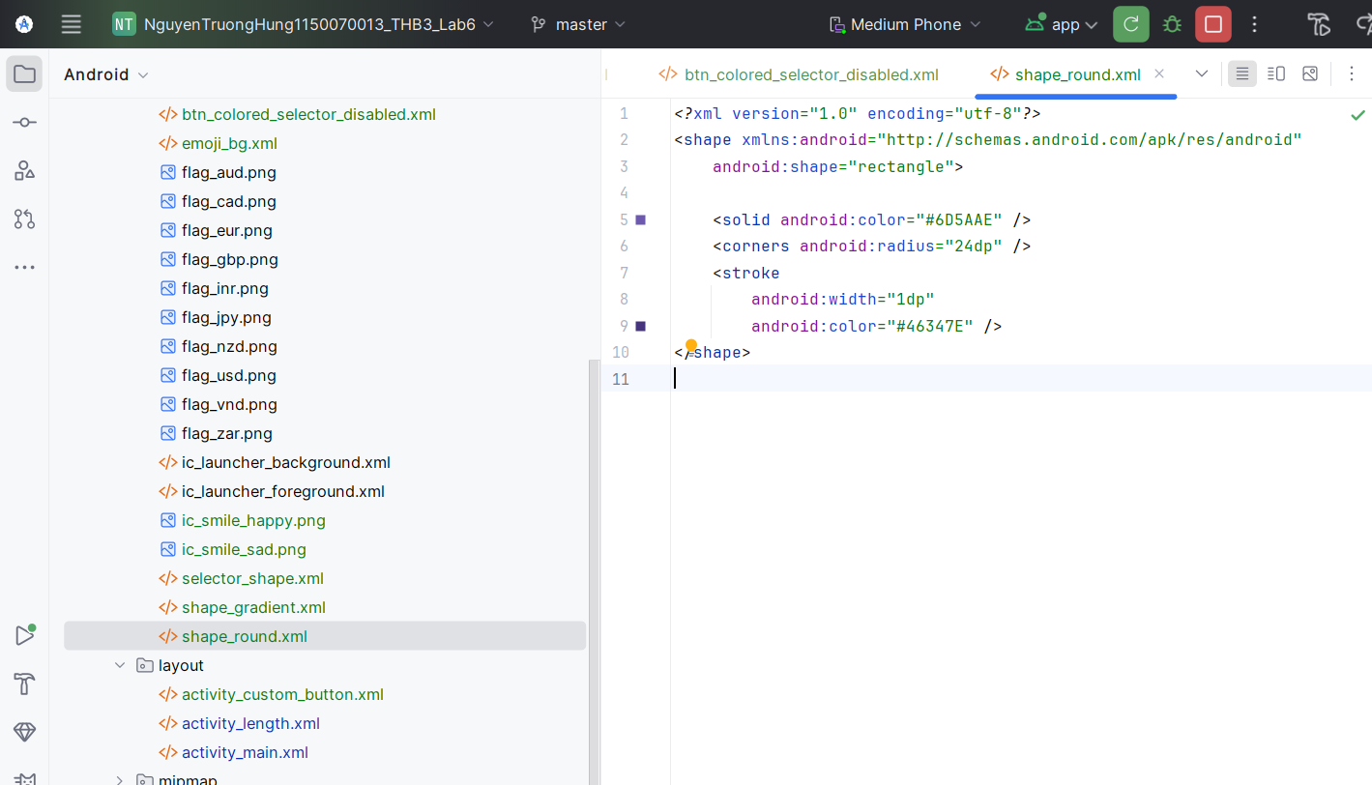

shape_gradient.xml – nút xanh gradient:
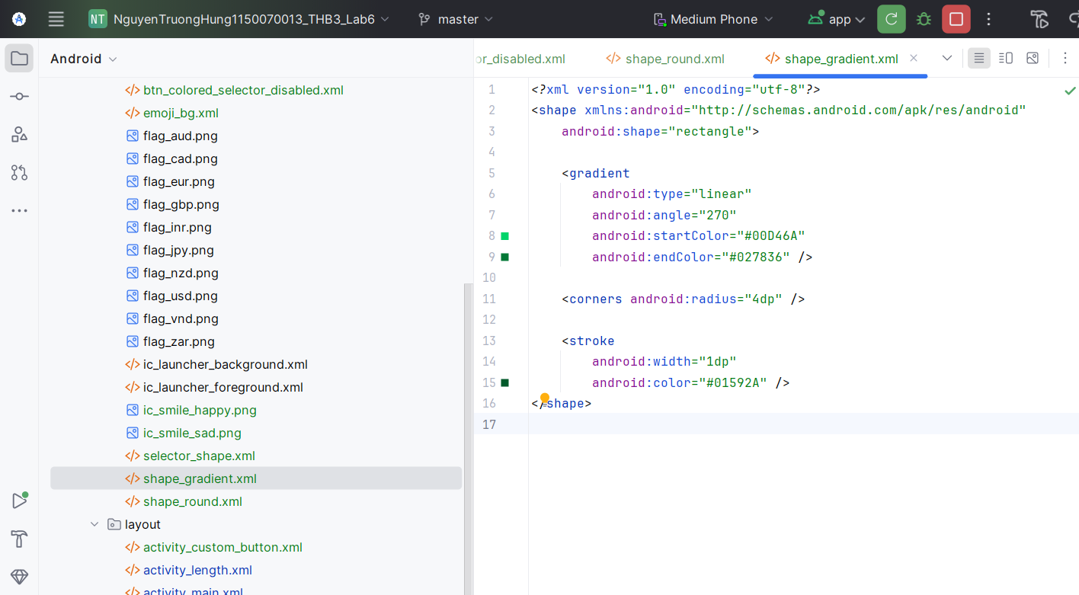

selector_shape.xml – nút đỏ / xanh khi nhấn:
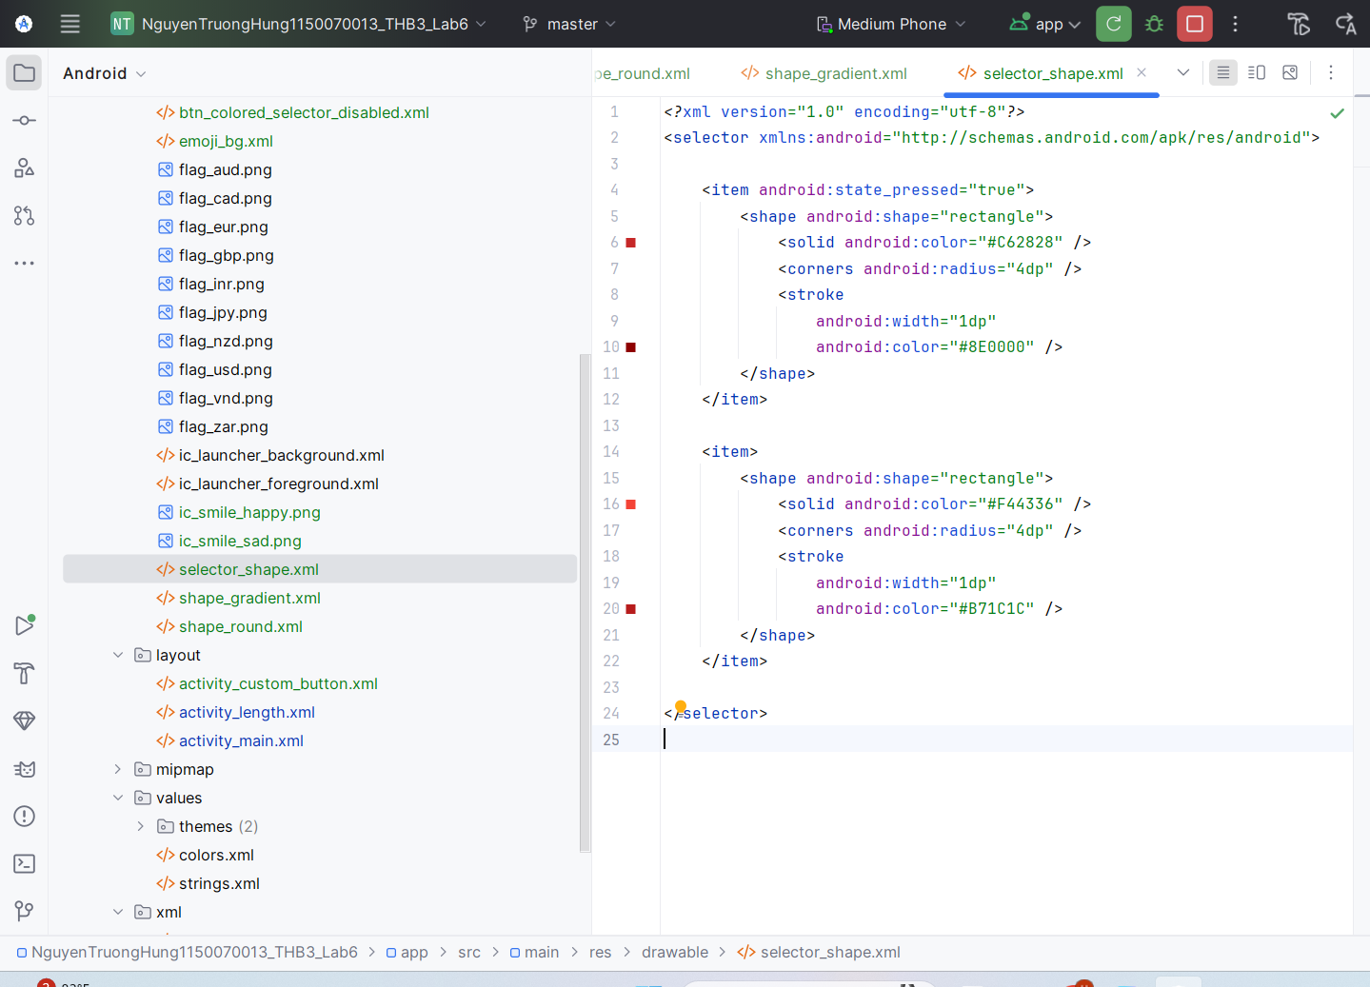
emoji_bg.xml – khung cho icon mặt cười:
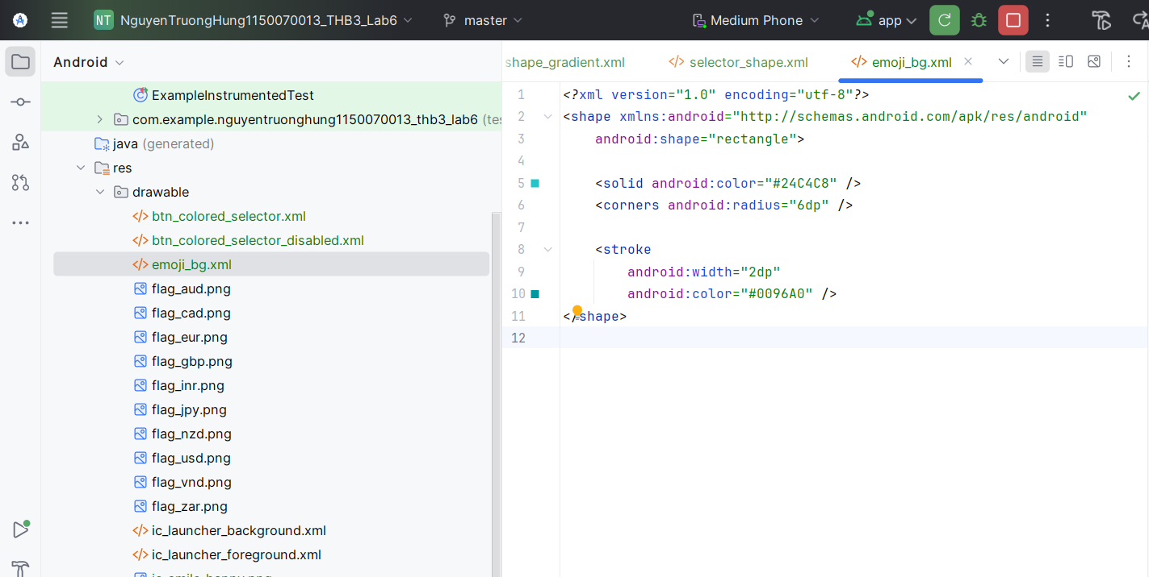

Bước 4 – Code cho CustomButtonActivity:
